**Experiment no 12**

## Aim:- Creation of Enterprise Reports using SQL Server Reporting services SSRS.

## Theory:-

## Scenario:-

## Step1:- Open the MS Visual Studio 2019 modifier to check whether the “Data Storage and processing” module is install or not.

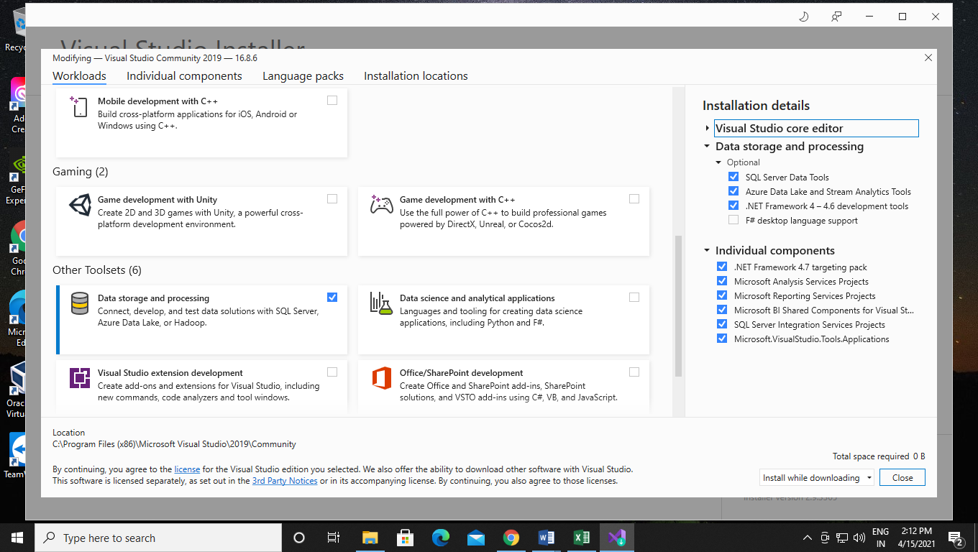

Step 2:- After installing the module go to “Create Project Manager” in that search for “Report Server Project Wizard” and “Report service Project”.

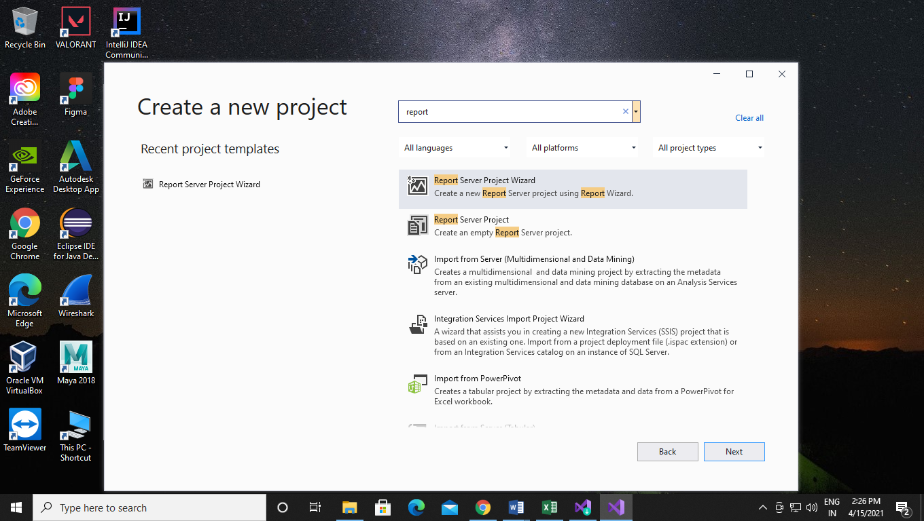

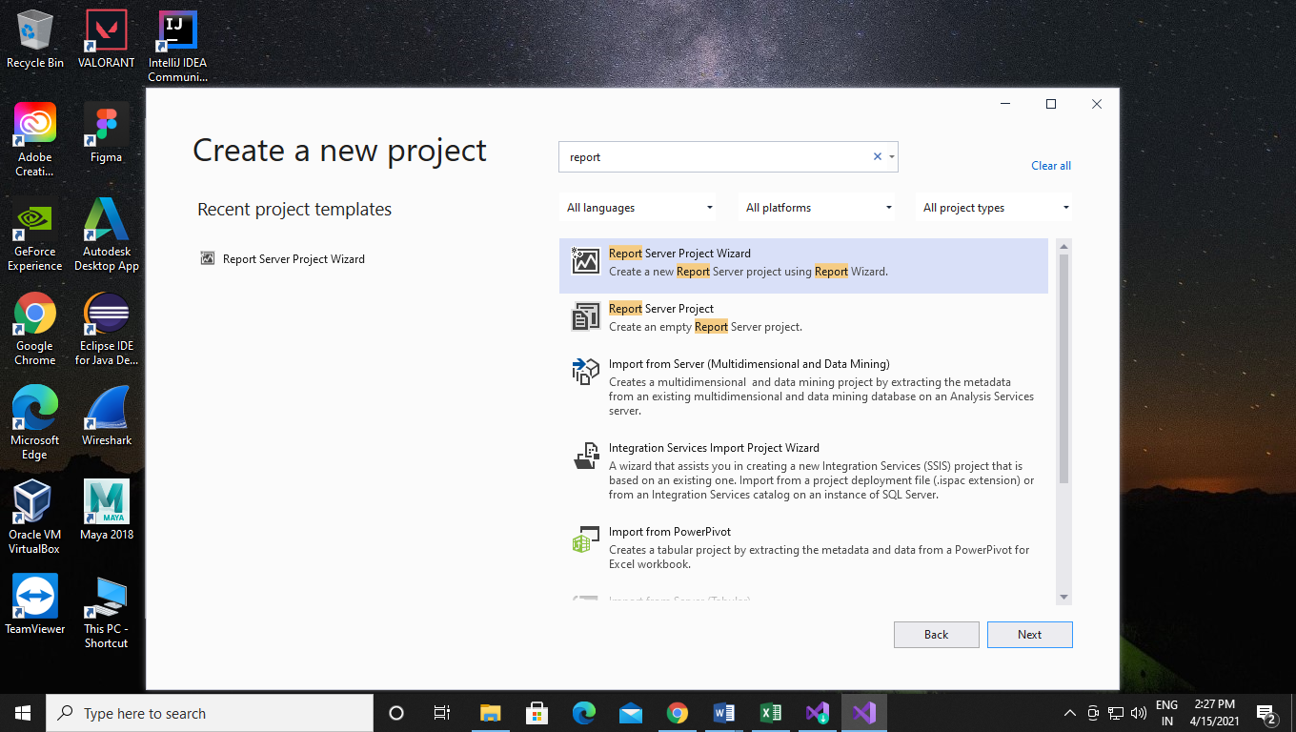

Step 3:- Click on the next button by selecting the Report server project Wizard and give your project name and set path and click on create.

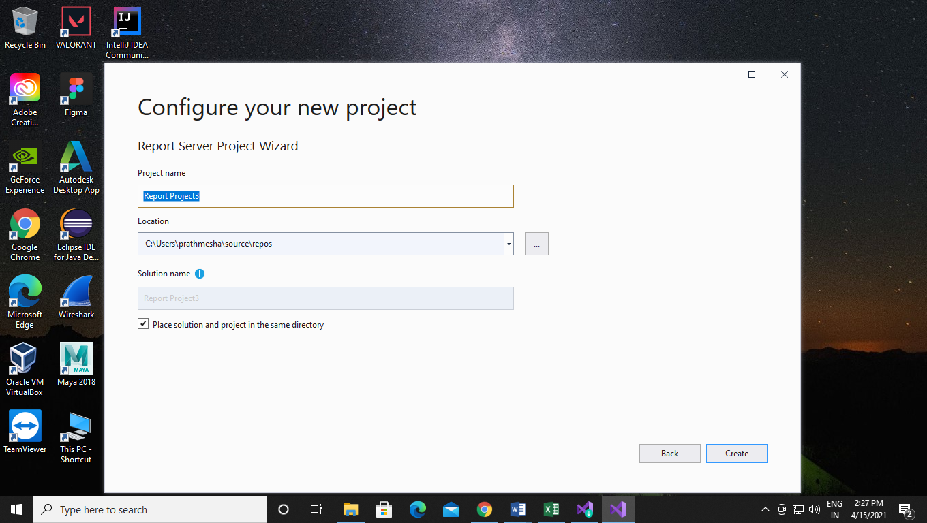

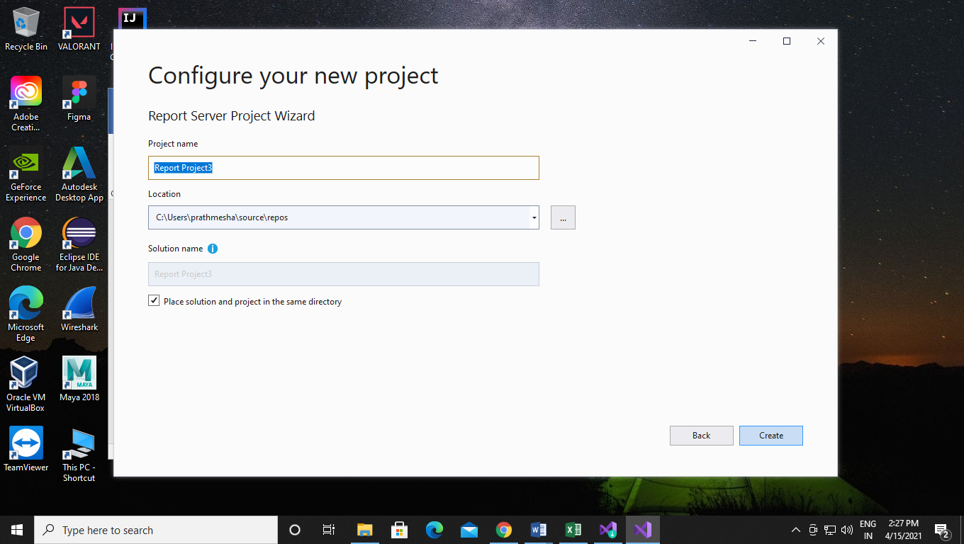

Step4:- After clicking on the create button you will see the report wizard and click on next.

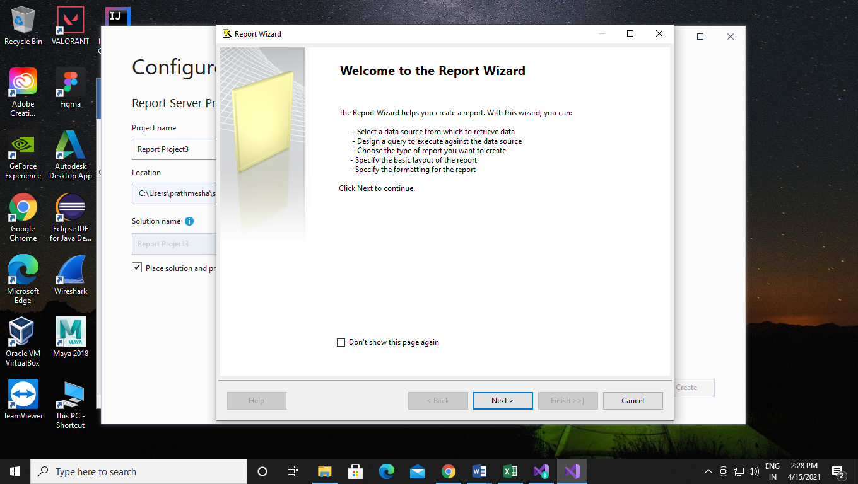

Step 5:- After clicking the next button you will get the select data source window where you have to create a data source and select its type to “Microsoft SQL Server”. And After that click on the edit button.

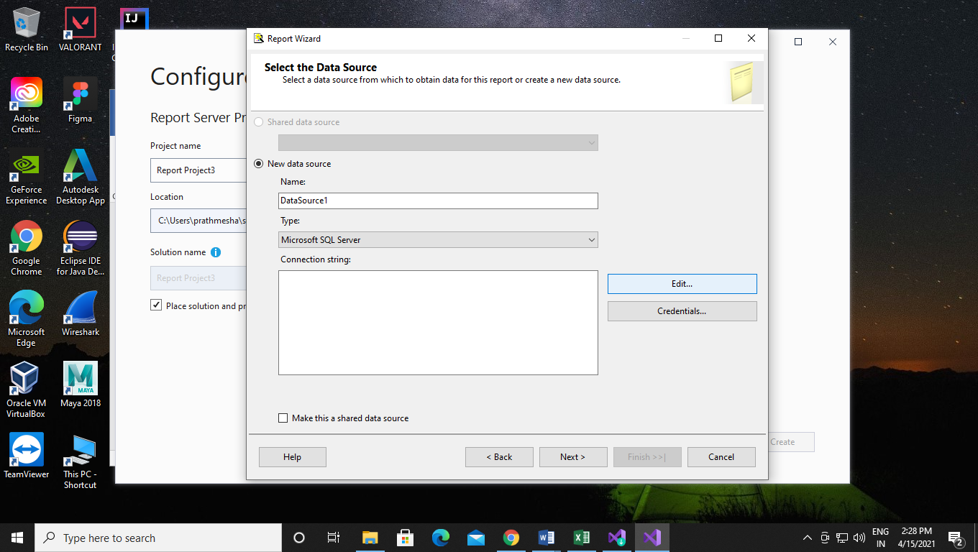

Step 6:- Before go for edit open up your SSMS and in that you have copy the server name and after that connect to the server.

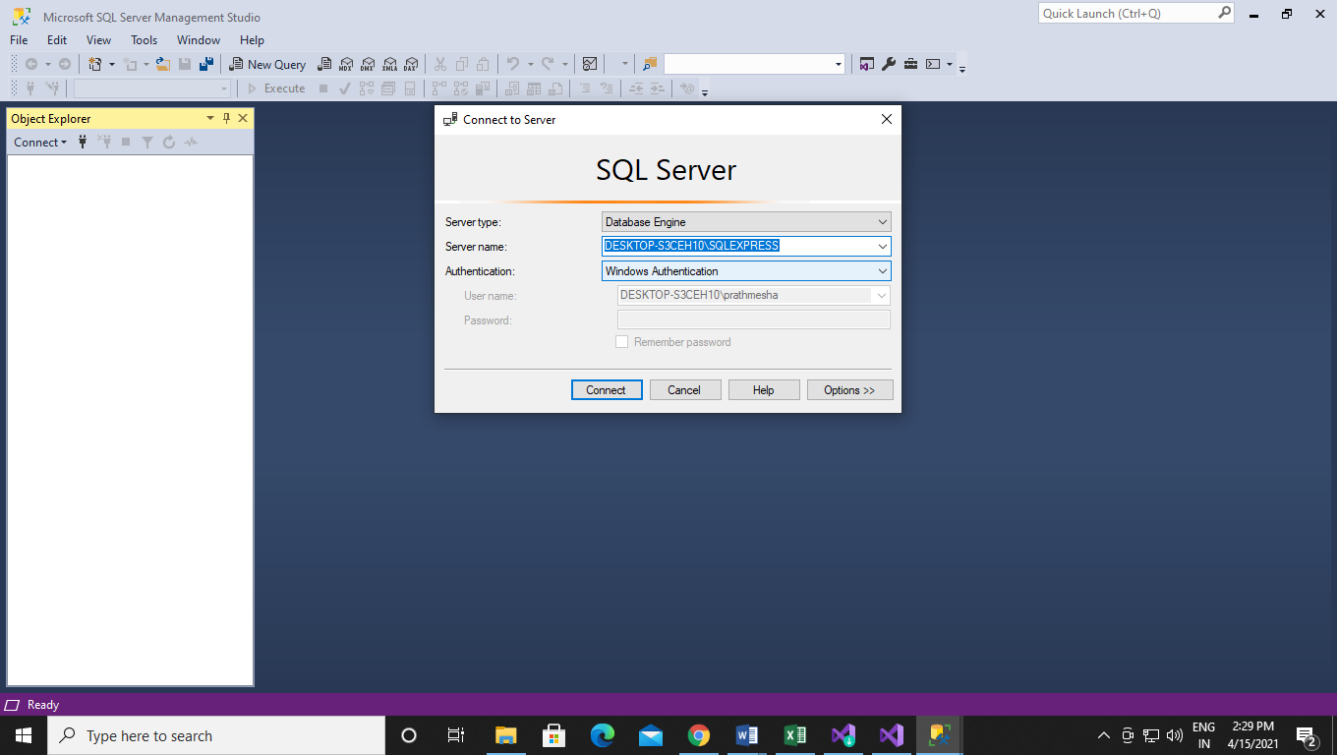

Step 7:- After connecting to the server you have to check in the data snap sheet where you have to find whether there is any data source name is existing or not. Here I have “emp” as my data base.

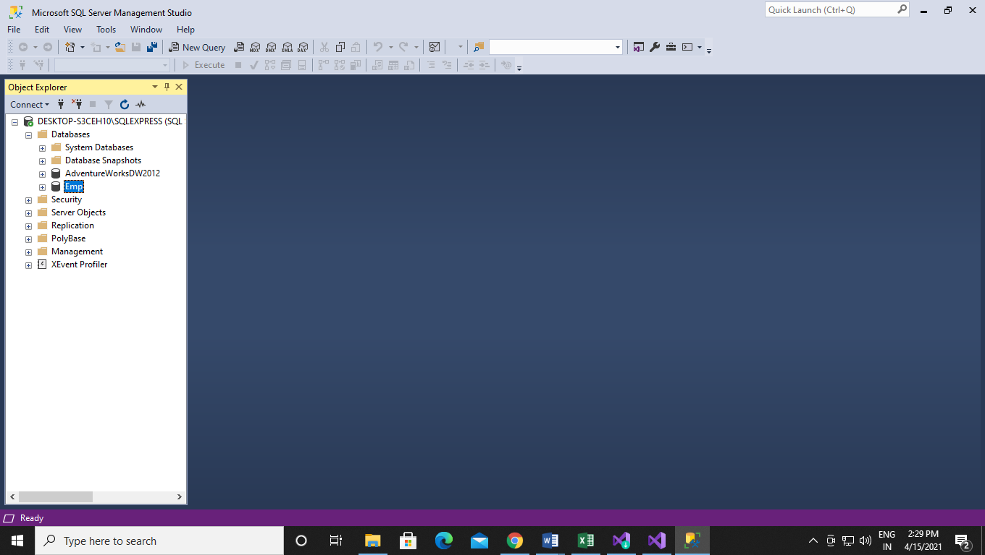

Step 8:- After some configuration in the SSMS go back to the report server wizard where we have left the edit part. Now in this you have to copy your server name and enter the database which do you have available and click on the OK button.

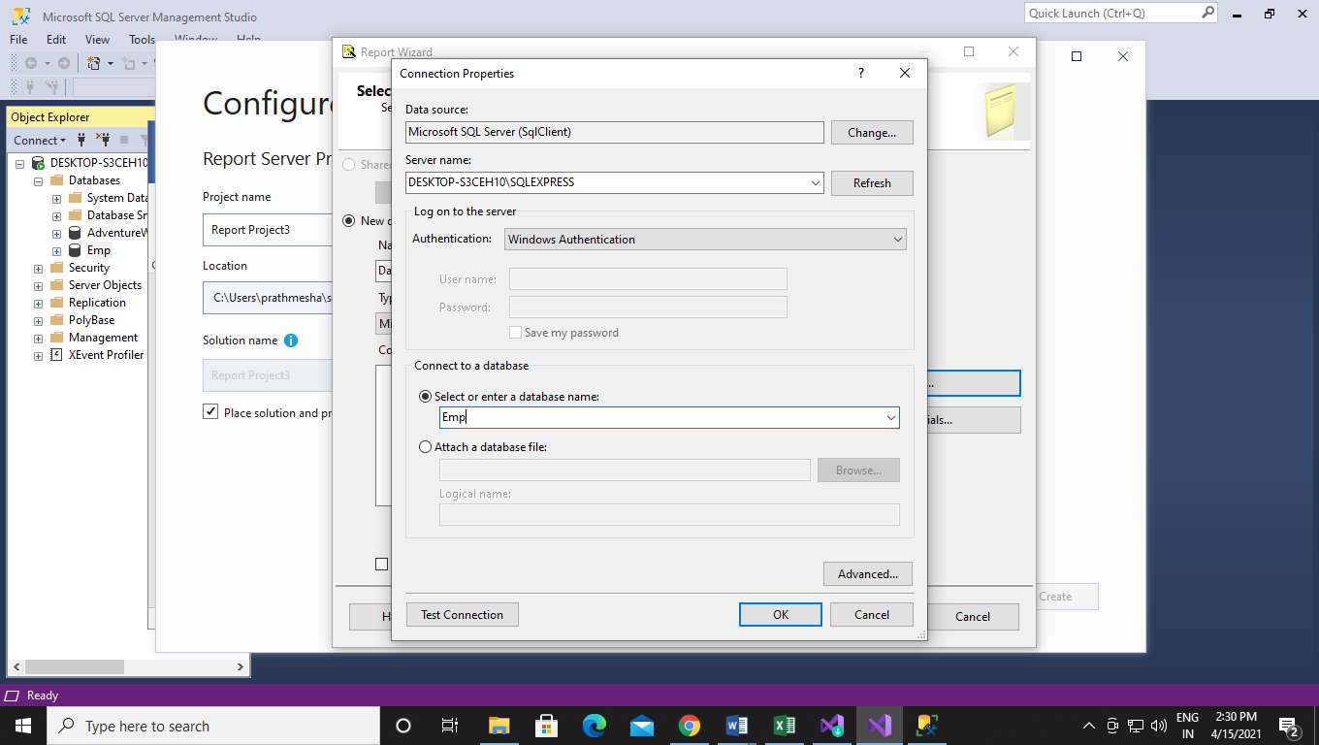

Step 9:- Now after clicking on ok button you will get Design Query builder window where you have to click on query builder button.

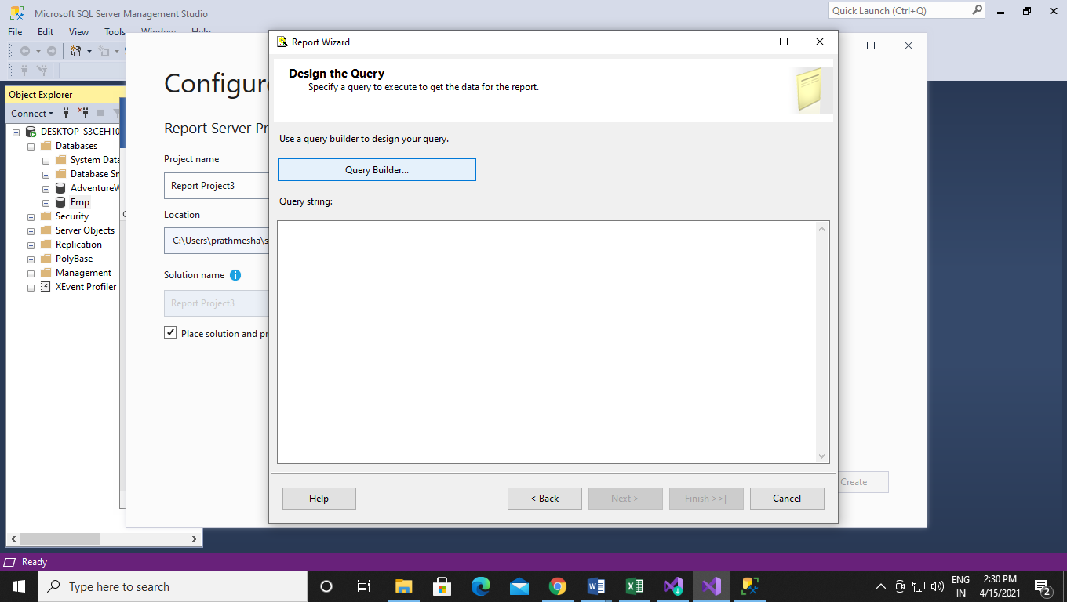

Step 10:- After clicking on the query builder you will get query designer window in that you have select the last option called Add table .

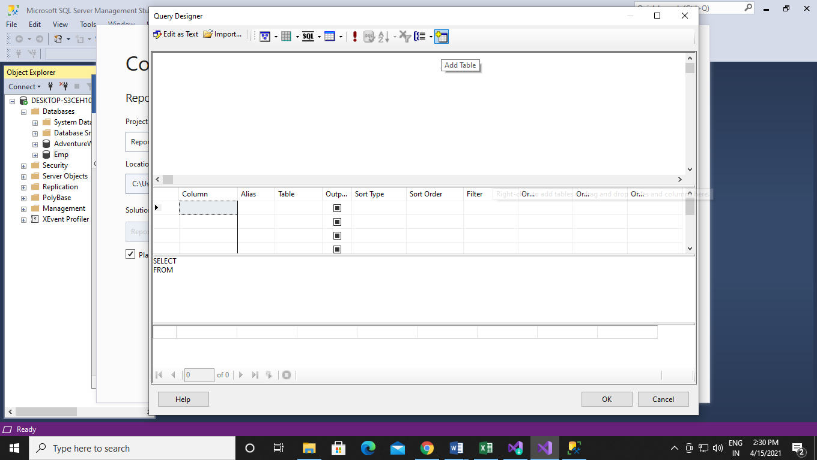

Step 11:- Select the employee table and click on the add.

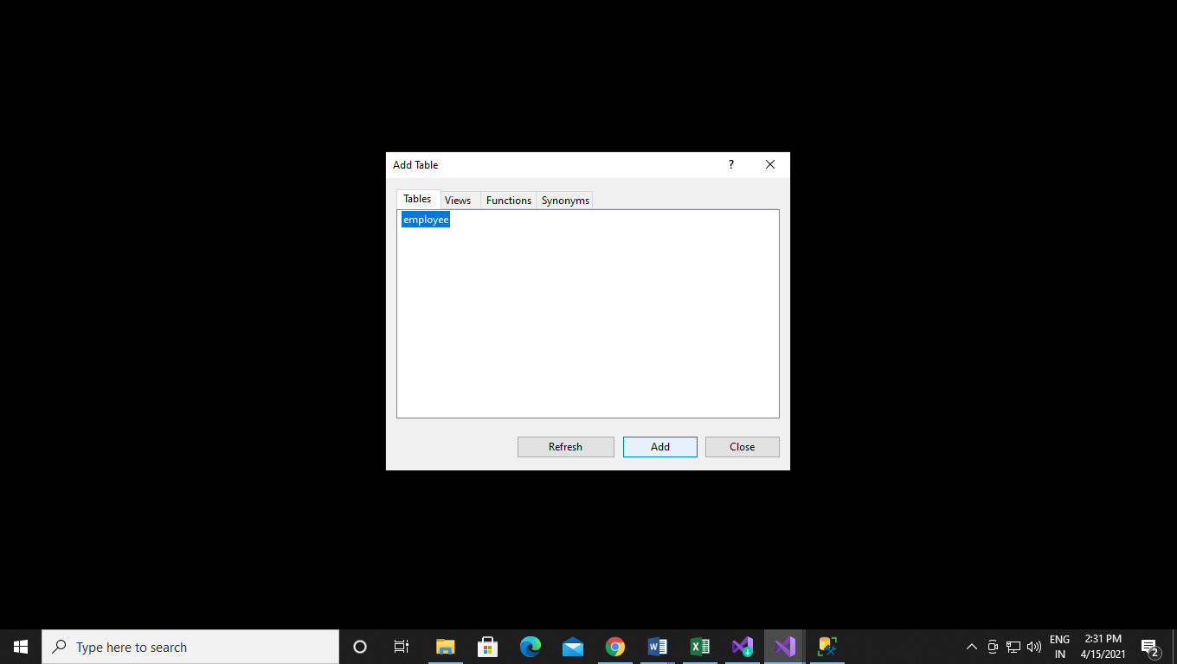

Step 12:- Configure your table as select on the employee table and click on the all columns option.

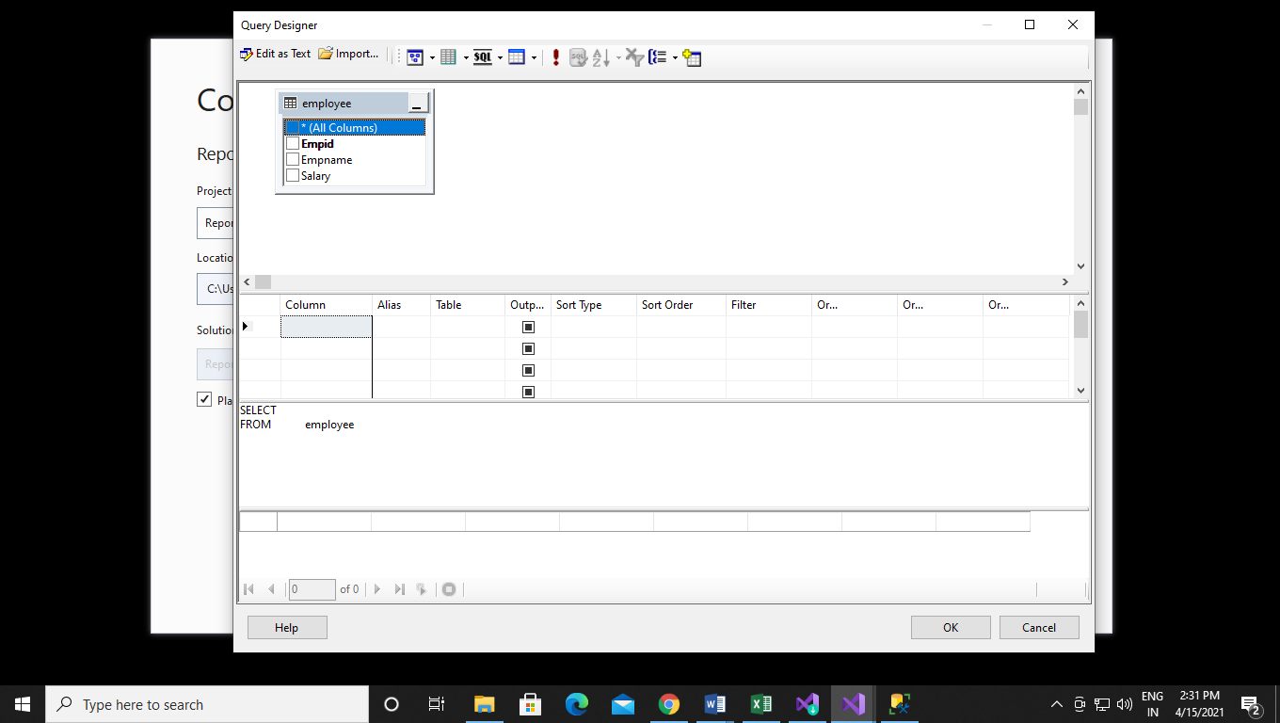

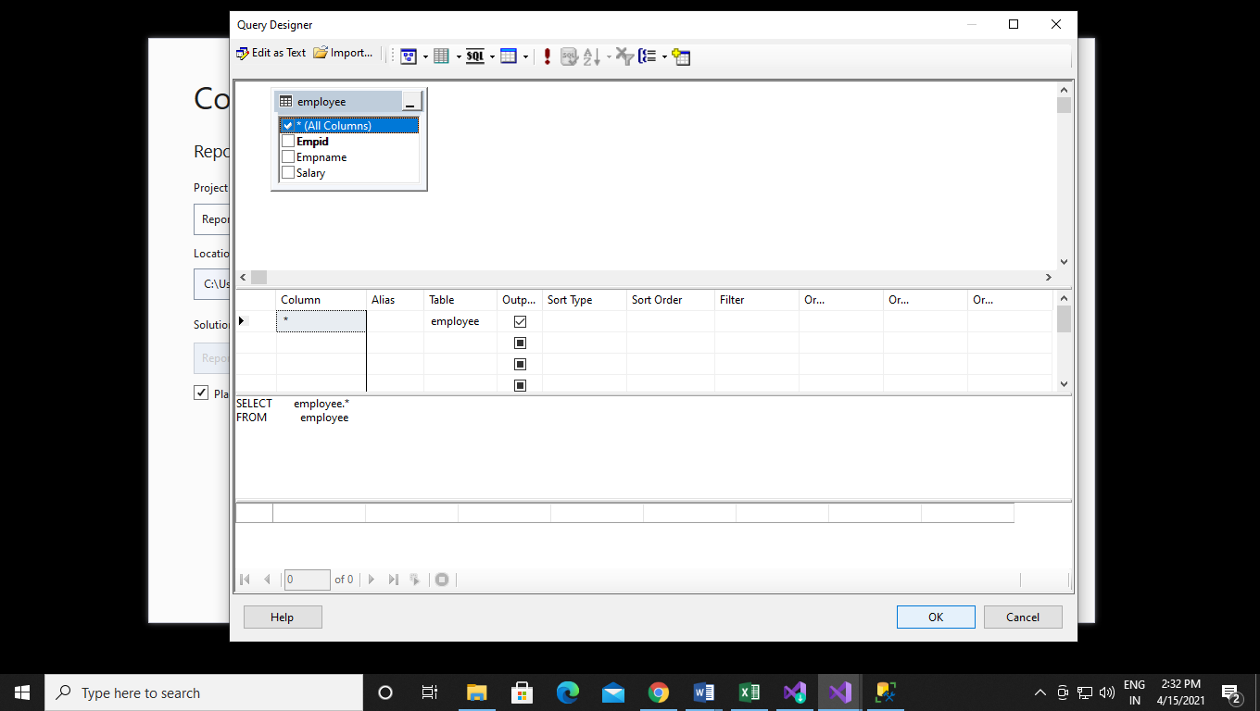

Step 12:- After select the all columns option just click on the ok button and you will back to the Report wizard and click on the next.

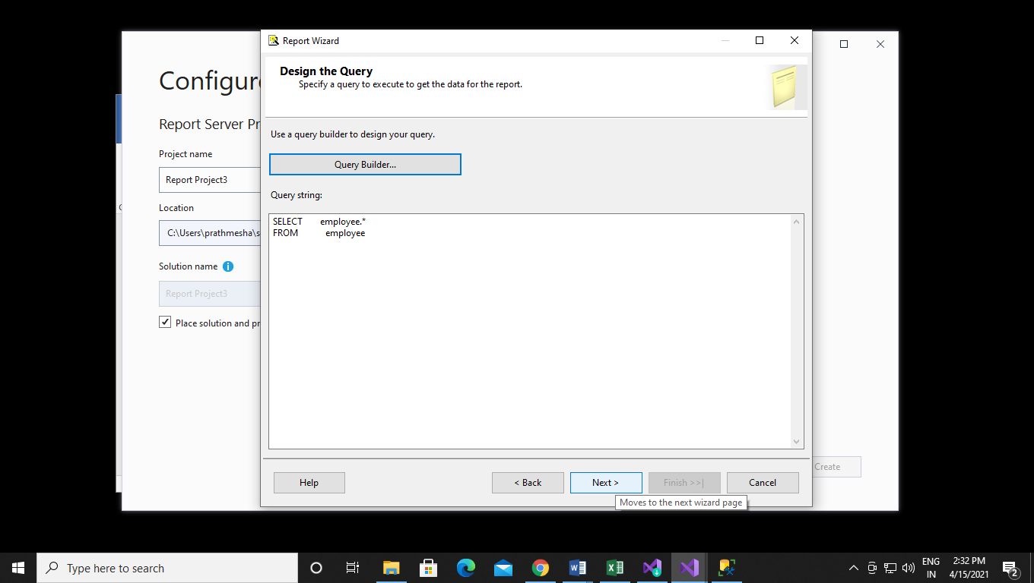

Step 13:- Select tabular format and click next.

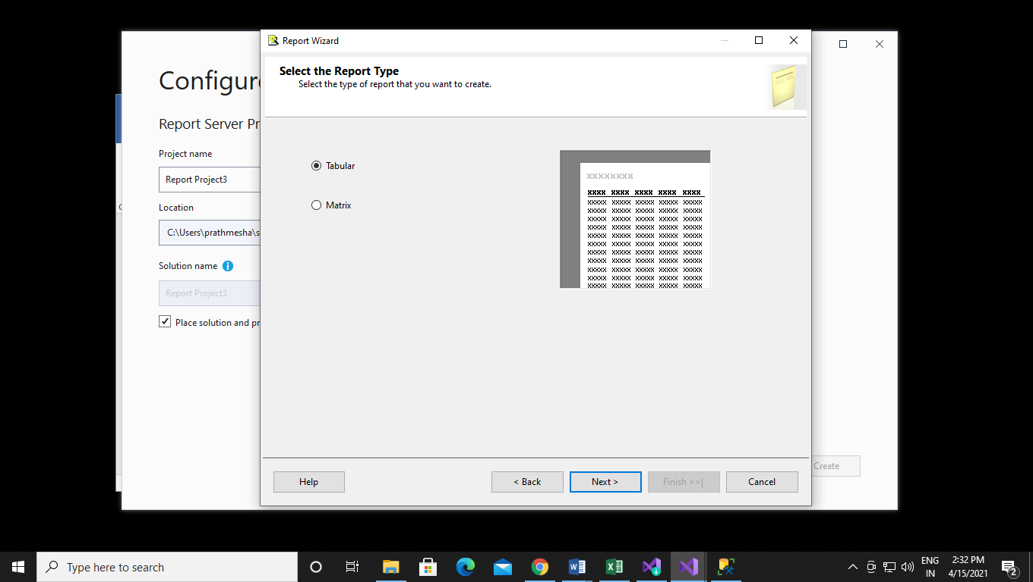

Step 14:-Click on next.

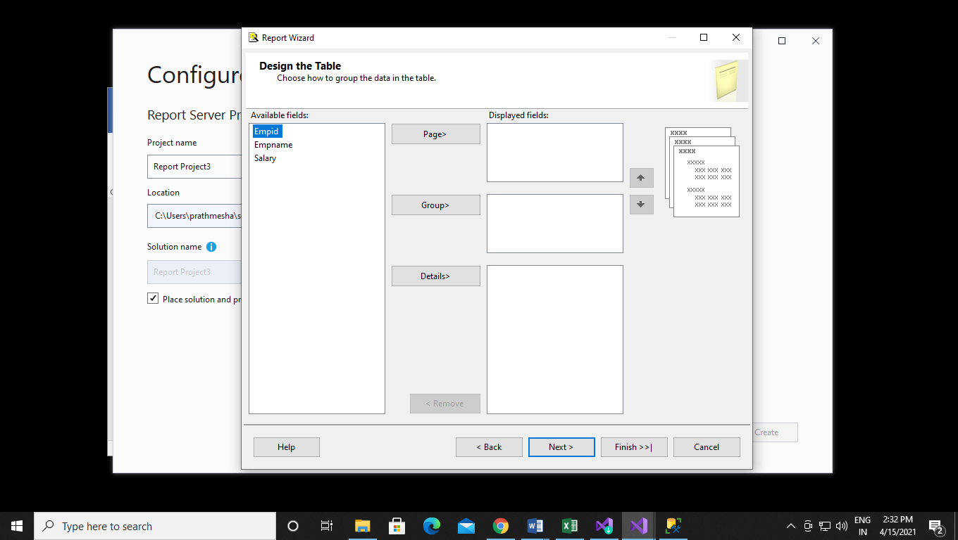

Step 15:- Give name to your report and click on finish.

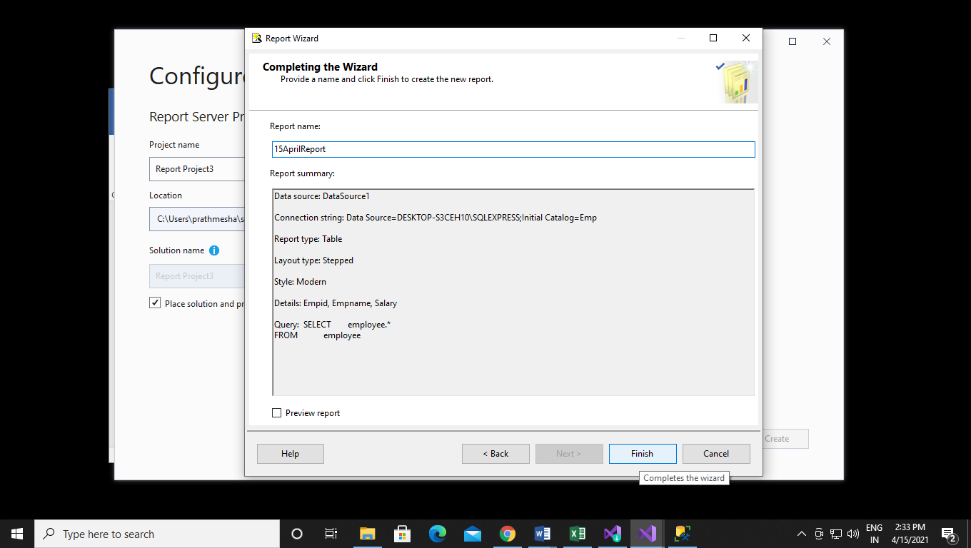

Step 16:- After clicked on finish button you will see your SSRS report is created successfully.

